**Subscribe Pro**

***SFRA Cartridge***



**Table of Contents**

Table of Contents

1. Summary 3

2. Component Overview 4

2.1 Functional Overview 4

2.2 Use Cases 4

2.3 Limitations, Constraints 5

2.4 Compatibility 5

2.5 Privacy, Payment 5

3. Implementation Guide 6

3.1 Setup 6

Initial Install 6

3.2 Configuration 12

Update Web Service Credentials 12

Setup Schedule Job to process orders with pending subscriptions 13

Configure Subscription Products 14

Configure OCAPI client 25

Configure Payments 27

3.3 Custom Code 44

Custom Code 45

3.4 External Interfaces 49

Service Profile 49

Service Credentials 50

Service Endpoints 51

3.5 Testing 52

Sandbox(es) 52

Integration Testing 52

4. Operations, Maintenance 54

4.1 Data Storage 54

4.2 Availability 54

4.3 Support 54

5. User Guide 55

5.1 Roles, Responsibilities 55

5.2 Business Manager 55

5.3 Storefront Functionality 56

Product Detail Page 56

Cart Page 57

Login Page 58

Order Summary Right Rail and Minicart 59

Order Confirmation Page 60

6. Known Issues 61

7. Release History 62

# Summary

This document provides technical instructions for installing the Commerce Cloud Integration LINK integration that lets you integrate Subscribe Pro product subscriptions with a Commerce Cloud storefront.

This cartridge integrates Salesforce Commerce Cloud with the Subscribe Pro Subscription Commerce Platform.

This integration requires deployment of a new cartridge and modification of Storefront code.

A subscription to the Subscribe Pro solution is required to use this cartridge.

Sandbox (testing) environments are available.

The provided “int_subscribe_pro_sfra” cartridge is implemented using StroreFront Reference Architecture.

This integration is based on the SFRA Demo Store provided by Commerce Cloud.

# Component Overview

## Functional Overview

Subscribe Pro enables brands and retailers to add subscription commerce, auto-ship, continuity, clubs, boxes and recurring billing features to their existing eCommerce site, fully integrated with their existing eCommerce technology. Subscribe Pro supports supports recurring payments via credit card and eCheck, with pre-built integrations for all common payment gateways. Contact us today to find out how our solution can help you implement a product subscription program.

## Use Cases

**Scenario**: A user visits a site that has subscription products available to purchase and would like to purchase those Products one time in order to try the product out before signing up for a recurring subscription.

**Result**: User will be presented with various options to subscribe to the subscription product with one of the options being a one time purchase. The user should be able to add this product to cart and checkout as if the product is a normal product in the catalog. Messaging should be present throughout checkout to inform the user that this is a one time purchase.

**Scenario**: A user visits a site that has subscription products available to purchase and would like to purchase a subscription product on a recurring interval automatically.

**Result**: User will be presented with various options to subscribe to the subscription product with one of the options being a subscription. The user should be able to add this product to cart and checkout as if the product is a normal product in the catalog. Messaging should be present throughout checkout to inform the user that this is a subscription purchase and display the interval they have chosen for repeat orders.

**Scenario:** A user has added some subscription products to their Basket and would like to adjust some of the values.

**Result:** User will be presented with options to change their subscription settings on the Cart Page. The user will also be able to click the “edit” link, on the subscription product, and change the subscription options in the quick view dialog.

**Scenario:** User has purchased a subscription product. The next time the ProcessSubproSubscriptions is run the necessary details about the customer and the products purchased will be transmitted to Subscribe Pro and the order will be marked as having been processed.

## Limitations, Constraints

* Merchants must be enrolled at Subscribe Pro
* Subscription products must be configured at Subscribe Pro and Sales Force Commerce Cloud
* A Credit Card will be required for subscription products
* Customers must be logged into the storefront in order to purchase subscription products
* Customer must save their Credit Card to their account in order to purchase subscription products

## Compatibility

Compatible OCAPI version 19.8

Compatible SFRA Version: 4.2.1

## Privacy, Payment

Customer profile data and payment information will be transferred and stored at Subscribe Pro.

This information includes:

* Name
* Email
* Address Details
* Saved Payment Instrument ID

Subscribe Pro will store the Customers saved Payment Instrument ID, in order to process recurring orders.

# Implementation Guide

## Setup

Subscribe Pro LINK SFRA integration uses the following cartridges:

* *int_subscribe_pro_sfra* – This cartridge contains the scripts, controllers, templates, metadata, and all other code necessary for implementing the Subscribe Pro integration with Salesforce Commerce Cloud SFRA.

Complete the following steps to install the cartridge.

### Initial Install

***Compilation***

Prior to uploading the Subscribe Pro SFRA cartridge you will need to compile the Javascript and CSS.

1. First create a directory called LINK_subscribepro.
2. Next, inside this directory, clone the salesforceCommerceCloud/storefront-reference-architecture salesforceCommerceCloud/link_subscribepro repositories
3. Make sure you have installed the sgmf-scripts module.
4. Run sgmf-scripts --compile js && sgmf-scripts --compile css

Next, you can upload your cartridge to your SFCC site.

1. Ensure a dw.json file exists with the credentials to upload to the correct store and deployment version.
2. Run sgmf-scripts --uploadCartridge int_subscribe_pro_sfra

#### Update Site's cartridge path

1. Navigate to *Administration > Sites > Manage Sites > [SiteName] > Settings tab*.
2. Add “int_subscribe_pro_sfra:” in the cartridge path to the left of “app_storefront_base” in the effective cartridge path.
3. Click “Apply”.

#### Install Services, Meta Data, and ProcessSubproSubscriptions Job

* + - 1. First, package the contents of the Metadata directory (including the site_import directory) into a Zip archive called site_import.zip.
      2. Navigate to Administration > Site Development > Site Import & Export
      3. Upload the site_import.zip archive and import it.

After the import is complete, the following system object definitions should include these additional attributes.

#### System object definitions

|  |  |  |  |
| --- | --- | --- | --- |
| ***CustomerAddress*** | | | |
| **ID** | **Name** | **Type** | **Description** |
| subproAddressID | Subscribe Pro Address ID | String | This attribute will contain the address id that is returned from Subscription Pro upon creating this address in the Subscribe Pro system. |
| ***CustomerPaymentInstrument*** | | | |
| **ID** | **Name** | **Type** | **Description** |
| subproPaymentProfileID | Subscribe Pro Payment Profile ID | String | This attribute will contain the payment profile id that is returned from Subscription Pro upon creating payment profile record in the Subscribe Pro system. |
| subproCCPrefix | Credit Card Prefix | String | This attribute will contain the first 6 digits of the customers Credit Card, to be sent to Subscribe Pro. |
| ***Order / Basket*** *Basket duplicates the order attributes so that they will automatically be passed from one to another.* | | | |
| **ID** | **Name** | **Type** | **Description** |
| subproContainsSubscriptions | Contains Subscriptions | Boolean | This attribute will be used to quickly assess if an order has subscriptions contained within it |
| subproSubscriptionsToBeProcessed | Subscriptions to be processed | Boolean | This attribute will note whether or not this order has subscriptions that need to be processed. This value will be set to true if any products in the basket have subscriptions and will be set to false after those subscriptions have been processed |
| ***OrderAddress*** | | | |
| **ID** | **Name** | **Type** | **Description** |
| subproAddressID | Subscribe Pro Address ID | String | This attribute will contain the address id that is returned from Subscription Pro upon creating this address in the Subscribe Pro system. |
| customerAddressID | SFCC Customer Address ID | String | This attribute will contain the SFCC customer address id. This information may be useful when a customer is updating subscription options after an order has been placed. |
| ***Product*** | | | |
| **ID** | **Name** | **Type** | **Description** |
| subproSubscriptionEnabled | Subscription Enabled | Boolean | This will decide whether or not the PDP should attempt to show subscription information |
| ***ProductLineItem*** | | | |
| **ID** | **Name** | **Type** | **Description** |
| subproSubscriptionOptionMode | Subscription Option Mode | String | This attribute will contain a value for whether or not if this product is subscription or a one time purchase. Possible values are:  onetime_purchase  subscription |
| subproSubscriptionSelectedOptionMode | Subscription Selected Option Mode | String | This attribute will contain subscription mode which was chosen on this ProductLineItem |
| subproSubscriptionInterval | Subscription Refill Interval | String | This attribute will contain the user selected time interval to refresh a subscription product |
| subproSubscriptionAvailableIntervals | Subscription Available Intervals | String | This attribute will contain a string with names of available subscription refill intervals, separated by comma |
| subproSubscriptionCreated | Subscription Created | Boolean |  |
| subproSubscriptionDateCreated | Subscription Date Created | Date |  |
| subproSubscriptionID | Subscription ID | String | This will be populated when the order processing occurs and the actual subscription is created. |
| subproSubscriptionDiscount | Subscription Discount | Double | This attribute will contain subscription discount offered on this product, as either a percentage or a fixed price, depending on the value of the subproSubscriptionIsDiscountPercentage property |
| subproSubscriptionIsDiscountPercentage | Subscription Is Discount Percentage | Boolean | This attribute will contain true if the discount on the product specified as a percentage or false if it is a fixed price amount. |
| ***Profile*** | | | |
| **ID** | **Name** | **Type** | **Description** |
| subproCustomerID | Subscribe Pro Customer ID | String | This attribute will contain the customer id that is returned from Subscription Pro upon creating this customers records in the Subscribe Pro system. |
| **Site preferences**  *Please configure the following site preferences:* | | | |
| **ID** | **Name** | **Type** | **Description** |
| subproEnabled | Subpro Enabled | Boolean | On/off switch for Subscription features. |
| subproCheckoutLoginMsg | Subpro Checkout Login Message | String | This attribute will contain a message that informs customer that he/she needs to be logged in as a registered customer to proceed checkout with SubPro Subscription products |
| subproCreditCardRequirementMsg | Subpro Credit Card Requirement Message | String | This attribute will contain an error message noting that a credit card is required for subscriptions |
| subproOrderProcessingErrorMail | Subscribe Pro Order Processing Error Mail | String | An email address that order subscriptions processing failures will be sent to |
| subproWidgetScriptUrl | Subscribe Pro Widget Script Url | String | URL to Subscribe Pro Widget Script |
| subproAddressWidgetScriptUrl | Subscribe Pro Address Book Widget Script Url | String | URL to the Subscribe Pro Address Book Widget Script |
| subproWalletWidgetScriptUrl | Subscribe Pro Wallet Widget Script Url | String | URL to the Subscribe Pro Wallet Widget Script |
| subproApiBaseUrl | Subscribe Pro API Base Url | String | Subscribe Pro API Base URL |
| subproAPICredSuffix | Suffix to append to the Subscribe Pro Web Service Credentials | String | Suffix to append to the Subscribe Pro Web Service Credentials |
| subproSubscriptionsWidgetConfig | Subscribe Pro Subscriptions Widget Custom Config | Text Area | JSON object string containing configuration for widget theme and display customization. |
| **Payment Card** | | | |
| **ID** | **Name** | **Type** | **Description** |
| subproCardType | SubPro Card Type | String | Credit Card Type that matches the Credit Card Types at Subscribe Pro |

## Configuration

### Update Web Service Credentials

1. Get your Client ID and Client Secret in Subscribe Pro BM:  
   <https://platform.subscribepro.com/system/client>

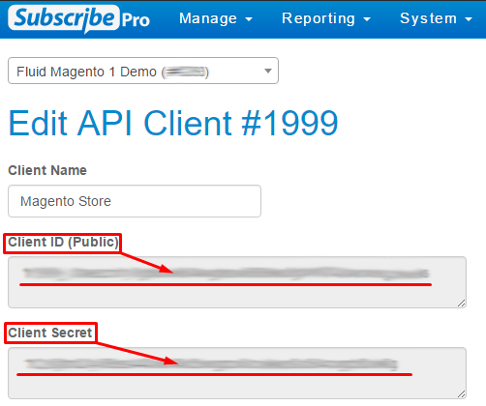

1. Navigate to *Administration > Operations > Services > Service Credentials > subpro.http.cred - Details*
2. Use Client ID as User and Client Secret as Password:

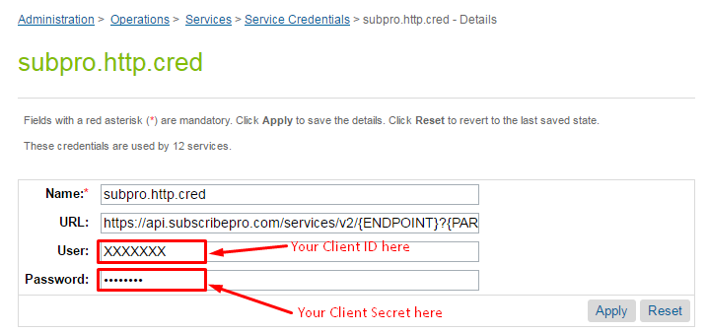

1. Navigate to *Administration > Operations > Services > Service Credentials > subpro.http.cred.oauth - Details*
2. Use Client ID as User and Client Secret as Password (the same as above).

### 

### 

### Turn on Subscribe Pro Cartridge Storefront Features

Our cartridge adds an on/off switch in the configuration that allows you to enable or disable the frontend features of our integration.

Navigate to Merchant Tools > Site Preferences > Custom Preferences > Subscribe Pro, and find the Subscribe Pro Enabled setting. Set this to Yes to turn it on, or No to turn it off.

### Setup Schedule Job to process orders with pending subscriptions

The job will process all orders that have any subscriptions that need to be processed.

Configure job parameters:

1. Navigate to *Administration > Operations > Job Schedules > ProcessSubproSubscriptions* job.
2. On tab *Schedule and History* set run interval (default is every 15 minutes).
3. Open *Step Configurator* tab, choose *ProcessSubproSubscriptions-Process* workflow.
4. Set (***in hours***) custom parameter *ordersProcessInterval* to define what the start time for the search placed orders should be.
5. Click “Assign” button.
6. Additionally, check that the site scope is set properly.

### Configure Subscription Products

To configure products which will have a subscription you’ll need to make changes to SFCC Business Manager as well as to Subscribe Pro Business Manager.

There are different type of products that can be configured:

* Standard Product
* Variation Product
* Variation Masters
* Product Bundles
* Product Sets
* Option Product

Below described action you need to perform to configure each type of product.

#### Standard Product

Standard Product is a product that is sold and displayed alone and does not have variations, such as different sizes or colors. If you include a standard product in a product set or product bundle, it is considered a set product or bundled product, and not a standard product.

##### Configuring Product on the Commerce Cloud Platform

The PDP page will take the Commerce Cloud Product ID and make an API request to the Subscribe Pro Products API Endpoint using the Commerce Cloud Product ID as the "sku" parameter.

The following image shows the Product ID that should be configured as a SKU in the Subscribe Pro Platform.

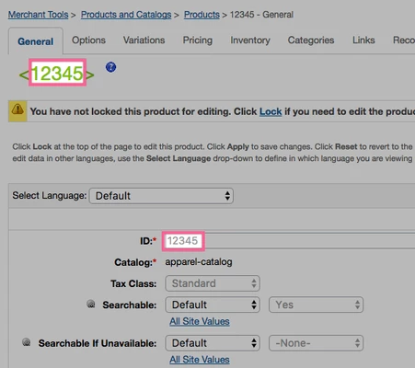

This API call will only be attempted if the Commerce Cloud Product has the: **Subscription Enabled** custom attribute set to: **true**.

The following image shows this setting in the following Business Manager Module:

*Merchant Tools > Products and Catalogs > Products*

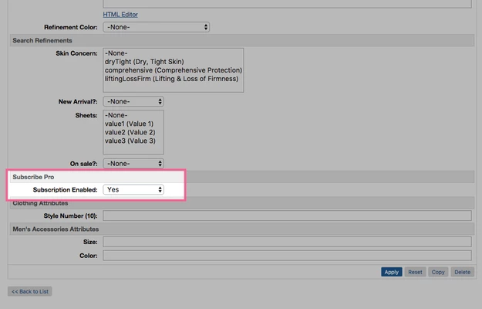

##### Configuring Product on the Subscribe Pro Platform

In addition to configuring the product on Commerce Cloud, the product will also need to be configured on the Subscribe Pro Platform.

<https://platform.subscribepro.com/login>

Subscription products can be managed on the platform at: *Manage > Subscription Products*

Within this module a new subscription product should be created that has a SKU that matches the Commerce Cloud Product ID.

The following is an example of a configured product that will match the product provided above for Commerce Cloud:

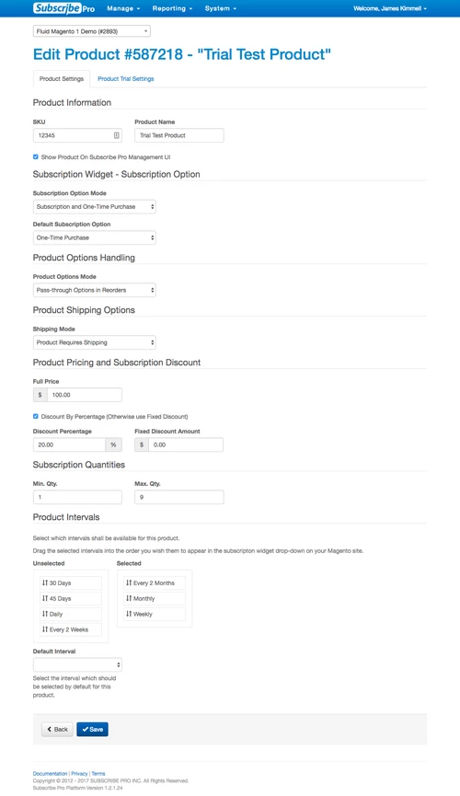

#### Variation Product

Variation Product is a product that is a specific variation. For example, if a Vegas brand t-shirt is represented by a variation master, then a product variation is a size 10, blue Vegas brand t-shirt.

Variation products associated with the same variation master share most of the attributes defined for the product master, but have their own product IDs and images.

Variation Products should be configured the same way as a “Standard Product”. See instructions above.

#### Variation Masters

Variation Masters is a product that represents all the variations for a particular product. For example, a specific style of t-shirt.

A variation master cannot be purchased directly, only product variations with specific variation information can be purchased. For example, if a master has color and size variation attributes, you must specify the color and size of a specific variant to purchase it.

If you have more than three variation attributes, you might want to consider using options.

To enable subscriptions for variation master products:

1. A Subscribe Pro Subscription Product will need to be created for each of the Variants contained within the Master Variant.
2. The master variant will need to have the "Subscriptions Enabled" custom attribute set to "yes".
   1. Any attributes set on the Master Product will flow down to all of the variant products, unless the variant product has overridden that particular attribute.

**Example:**

***Master Product (in Commerce Cloud)***

|  |  |
| --- | --- |
| **ID** | **Name** |
| 25752235 | Checked Silk Tie |

***Variant Product(s) (in Commerce Cloud)***

|  |  |  |
| --- | --- | --- |
| **Parent ID** | **ID** | **Options** |
| 25752235 | 682875090845 | Color: Cobalt |
| 25752235 | 682875719029 | Color: Navy |
| 25752235 | 682875540326 | Color: Yellow |

***Subscribe Pro - Subscription Products (in Subscribe Pro Platform)***

|  |  |  |
| --- | --- | --- |
| **ID** | **SKU** | **Name** |
| 587218 | 682875090845 | Checked Silk Tie - Cobalt |
| 587219 | 682875719029 | Checked Silk Tie - Navy |
| 587220 | 682875540326 | Checked Silk Tie - Yellow |

#### Product Bundles

Commerce Cloud Digital product bundles:

* Are a separate product with its own SKU and price
* Are unaffected by the price of the individual products
* Contain specified products in specified numbers

In respect to subscription products, product bundles can be treated the same as product variants. The end user will select subscription options for the entire bundle and the single product ID for the bundle is what will be configured and transmitted to Subscribe Pro when creating subscriptions.

See the instructions how to configure a Standard Product above.

Sales Force Commerce Cloud will automatically add all of the bundled products (children) to the Basket when the product bundle is added, whether it be from the storefront or from OCAPI.

The following is an example of an OCAPI request and response using product bundle: sony-ps3-bundle:

|  |
| --- |
| **Request** |
| {  "customer_info": {  "customer_no": "00000001",  "email": "jkimmell@fluid.com"  },  "billing_address": {  "first_name": "James",  "last_name": "Kimmell",  "address1": "14137 Louise Drive",  "city": "Cumberland",  "state_code": "MD",  "country_code": "US"  },  "product_items": [{  "product_id": "sony-ps3-bundle",  "quantity": 1  }],  "shipments": [{  "gift": false,  "shipping_method": {  "id": "001"  },  "shipping_address": {  "first_name": "James",  "last_name": "Kimmell",  "address1": "14137 Louise Drive",  "city": "Cumberland",  "state_code": "MD",  "country_code": "US"  }  }]  } |

|  |
| --- |
| **Response** |
| {  "_v":"17.3",  "_type":"basket",  "_resource_state":"22e95720919f1eaa894bda606664b5a61a9575e0a942a1452bbfdb7062da0f69",  "_flash":[  {  "_type":"flash",  "type":"PaymentMethodRequired",  "message":"No payment method ID was specified. Please provide a valid payment method ID.",  "path":"$.payment_instruments[0].payment_method_id"  }  ],  "adjusted_merchandize_total_tax":22.45,  "adjusted_shipping_total_tax":0.5,  "agent_basket":true,  "basket_id":"16f3006604e77fff7105caf63a",  "billing_address":{  "_type":"order_address",  "address1":"14137 Louise Drive",  "city":"Cumberland",  "country_code":"US",  "first_name":"James",  "full_name":"James Kimmell",  "id":"b600c40aec47165cacc48c7ad2",  "last_name":"Kimmell",  "state_code":"MD"  },  "channel_type":"callcenter",  "creation_date":"2017-04-19T15:26:23.314Z",  "currency":"USD",  "customer_info":{  "_type":"customer_info",  "customer_id":"abKT2hbWsyyV8alhk6VJg9Ow0E",  "customer_no":"00000001",  "email":"jkimmell@fluid.com"  },  "last_modified":"2017-04-19T15:26:23.360Z",  "merchandize_total_tax":22.45,  "notes":{  "_type":"simple_link",  "link":"https://subscribepro01-tech-prtnr-na02-dw.demandware.net/s/SiteGenesis/dw/shop/v17_3/baskets/16f3006604e77fff7105caf63a/notes"  },  "order_total":481.94,  "product_items":[  {  "_type":"product_item",  "adjusted_tax":22.45,  "base_price":449,  "bonus_product_line_item":false,  "bundled_product_items":[  {  "_type":"product_item",  "adjusted_tax":null,  "base_price":null,  "bonus_product_line_item":false,  "item_id":"94921b91f537474e71376abaf2",  "item_text":"Sony Playstation 3 Game Console",  "price":null,  "price_after_item_discount":null,  "price_after_order_discount":0,  "product_id":"sony-ps3-console",  "product_name":"Sony Playstation 3 Game Console",  "quantity":1,  "shipment_id":"me",  "tax":null,  "tax_basis":null,  "tax_class_id":"standard",  "tax_rate":0.05  },  {  "_type":"product_item",  "adjusted_tax":null,  "base_price":null,  "bonus_product_line_item":false,  "item_id":"6356afd70d4a120da36a9d3baf",  "item_text":"Nascar 09 (for Sony PS3)",  "price":null,  "price_after_item_discount":null,  "price_after_order_discount":0,  "product_id":"easports-nascar-09-ps3",  "product_name":"Nascar 09 (for Sony PS3)",  "quantity":1,  "shipment_id":"me",  "tax":null,  "tax_basis":null,  "tax_class_id":"standard",  "tax_rate":0.05  },  {  "_type":"product_item",  "adjusted_tax":null,  "base_price":null,  "bonus_product_line_item":false,  "item_id":"8b606524f0c7a7325cc4e4e23a",  "item_text":"Monopoly Here and Now: The World Edition (for Sony PS3)",  "price":null,  "price_after_item_discount":null,  "price_after_order_discount":0,  "product_id":"easports-monopoly-ps3",  "product_name":"Monopoly Here and Now: The World Edition (for Sony PS3)",  "quantity":1,  "shipment_id":"me",  "tax":null,  "tax_basis":null,  "tax_class_id":"standard",  "tax_rate":0.05  },  {  "_type":"product_item",  "adjusted_tax":null,  "base_price":null,  "bonus_product_line_item":false,  "item_id":"0798adadda95b0a5c4d282980f",  "item_text":"Eternal Sonata (for Sony PS3)",  "price":null,  "price_after_item_discount":null,  "price_after_order_discount":0,  "product_id":"namco-eternal-sonata-ps3",  "product_name":"Eternal Sonata (for Sony PS3)",  "quantity":1,  "shipment_id":"me",  "tax":null,  "tax_basis":null,  "tax_class_id":"standard",  "tax_rate":0.05  },  {  "_type":"product_item",  "adjusted_tax":null,  "base_price":null,  "bonus_product_line_item":false,  "item_id":"b0bfeff3a8214ea603c570d73b",  "item_text":"Warhawk (for Sony PS3)",  "price":null,  "price_after_item_discount":null,  "price_after_order_discount":0,  "product_id":"sony-warhawk-ps3",  "product_name":"Warhawk (for Sony PS3)",  "quantity":1,  "shipment_id":"me",  "tax":null,  "tax_basis":null,  "tax_class_id":"standard",  "tax_rate":0.05  }  ],  "item_id":"8ddceb64e1d3856008a753122a",  "item_text":"Playstation 3 Bundle",  "option_items":[  {  "_type":"option_item",  "adjusted_tax":0,  "base_price":0,  "bonus_product_line_item":false,  "item_id":"392333b488e166df0b46927548",  "item_text":"Extended Warranty: None",  "option_id":"consoleWarranty",  "option_value_id":"000",  "price":0,  "price_after_item_discount":0,  "price_after_order_discount":0,  "product_id":"000",  "product_name":"Extended Warranty: None",  "quantity":1,  "shipment_id":"me",  "tax":0,  "tax_basis":0,  "tax_class_id":"standard",  "tax_rate":0.05  }  ],  "price":449,  "price_after_item_discount":449,  "price_after_order_discount":449,  "product_id":"sony-ps3-bundle",  "product_name":"Playstation 3 Bundle",  "quantity":1,  "shipment_id":"me",  "tax":22.45,  "tax_basis":449,  "tax_class_id":"standard",  "tax_rate":0.05  }  ],  "product_sub_total":449,  "product_total":449,  "shipments":[  {  "_type":"shipment",  "adjusted_merchandize_total_tax":22.45,  "adjusted_shipping_total_tax":0.5,  "gift":false,  "merchandize_total_tax":22.45,  "product_sub_total":449,  "product_total":449,  "shipment_id":"me",  "shipment_total":481.94,  "shipping_address":{  "_type":"order_address",  "address1":"14137 Louise Drive",  "city":"Cumberland",  "country_code":"US",  "first_name":"James",  "full_name":"James Kimmell",  "id":"29410763e35c40915b515a0cdd",  "last_name":"Kimmell",  "state_code":"MD"  },  "shipping_method":{  "_type":"shipping_method",  "description":"Order received within 7-10 business days",  "id":"001",  "name":"Ground",  "price":9.99  },  "shipping_status":"not_shipped",  "shipping_total":9.99,  "shipping_total_tax":0.5,  "tax_total":22.95  }  ],  "shipping_items":[  {  "_type":"shipping_item",  "adjusted_tax":0.5,  "base_price":9.99,  "item_id":"1ad26e6d3776f228e7d56228d7",  "item_text":"Shipping",  "price":9.99,  "price_after_item_discount":9.99,  "shipment_id":"me",  "tax":0.5,  "tax_basis":9.99,  "tax_class_id":"standard",  "tax_rate":0.05  }  ],  "shipping_total":9.99,  "shipping_total_tax":0.5,  "taxation":"net",  "tax_total":22.95  } |

#### Product Sets

Product Set is a product that includes several products that are displayed together and can be purchased together or separately. For example, an accessories kit that includes a hairbrush, comb, and mirror, each of which can also be bought separately. Another common example is an outfit, with a jacket, shirt, and pants, which can be purchased together or each item can be purchased separately.

Unlike Product Bundles, Products Set Products are added to the cart individually. The end consumer has the option to add each product individually or to add all of the products at once.

When the consumer adds all of the products at once, the form fields for each individual product are preserved, for example quantity and subscription options.

Products within a product set can be configured the same as a standard product and the user will have the ability to configure the subscription options and interval for each individual product. See the instructions for configuring a Standard Product above.

#### Option Product

Commerce Cloud Digital, product options enable you to sell configurable products that have optional accessories, upgrades, or additional services. Options are always purchased with a product and cannot be purchased separately. They have their own price and display name, but do not have their own thumbnail images. They cannot be searched by the customer, but are usually visible on the product detail page.

Products that are configured with Product Options should be configured the same as a normal subscription product in Commerce Cloud and Subscribe Pro. The only difference with these products is that the Order Processing Script, that creates the subscription at Subscribe Pro, will also include any product options, selected for the product line item, in the platform_specific_fields attribute.

|  |
| --- |
| **Subscribe Pro Subscription Request** |
| {  "subscription":{  "customer_id":"348328",  "payment_profile_id":"410028",  "requires_shipping":true,  "shipping_address_id":455367,  "product_sku":"canon-powershot-e1",  "qty":1,  "use_fixed_price":false,  "interval":"Month",  "next_order_date":"2017-04-19T21:33:56.954Z",  "first_order_already_created":true,  "send_customer_notification_email":true,  "platform_specific_fields":{  "sfcc":{  "product_options":[  {  "id":"digitalCameraWarranty",  "value":"002"  }  ]  }  }  }  } |

These product options will need to be added to the Basket when recurring orders are placed through OCAPI. The following is an example of a Basket object, with a product option, that could be sent back to Commerce Cloud via OCAPI:

|  |
| --- |
| **OCAPI Basket Object** |
| {  "customer_info": {  "customer_no": "00000001",  "email": "jkimmell@fluid.com"  },  "billing_address": {  "first_name": "James",  "last_name": "Kimmell",  "address1": "14137 Louise Drive",  "city": "Cumberland",  "state_code": "MD",  "country_code": "US"  },  "product_items": [{  "product_id": "samsung-hl72a650",  "quantity": 1,  "option_items": [  {  "option_id": "tvWarranty",  "option_value_id": "002"  }  ]  }],  "shipments": [{  "gift": false,  "shipping_method": {  "id": "001"  },  "shipping_address": {  "first_name": "James",  "last_name": "Kimmell",  "address1": "14137 Louise Drive",  "city": "Cumberland",  "state_code": "MD",  "country_code": "US"  }  }]  } |

### Configure OCAPI client

Subscribe Pro will make use of the "Shop" Open Commerce API (OCAPI) in order to place recurring orders for subscription products. This will be accomplished server to server using a Business Manager login.

In Business Manager, under Administration > Site Development > Open Commerce API Settings, modify the Shop configuration to include the endpoint and method permissions listed in the **Documentation/okapi-example-configuration.json** file.

### Configure Payments

Subscribe Pro will make use of OCAPI to place orders on behalf of the customer. This is one of the reasons that a customer must be logged in and have a stored payment instrument in order to place an order with subscriptions.

#### Credit Cards

A Payment token and the Payment Instrument ID will be transmitted to Subscribe Pro as part of the Subscription creation process.

Credit Card tokenization will need to be implemented by a tokenization provider when this cartridge is implemented, on an actual site. This will be accomplished by making use of the: setCreditCardToken method in the PaymentInstrument object.

See SFCC documentation:

<https://documentation.demandware.com/DOC1/topic/com.demandware.dochelp/DWAPI/scriptapi/html/api/class_dw_order_PaymentInstrument.html>

#### Subscribe Pro - Payment Profile

Payment profile should be used to pay for subscriptions.

The use of this profile could be divided into two steps:

* creating subscription
* recurring subscription charging

##### Creating subscription

As part of the order processing script, we send the relevant Payment Data to the Subscribe Pro using the */vault/paymentprofile/external-vault end-point*.

The following is the relevant snippet of code in the Order Processing Logic:

***/int_subscribe_pro_sfra/cartridge/scripts/subpro/jobs/ProcessOrderSubscriptions.js***

|  |
| --- |
| /**  * Apple Pay otherwise assume Credit Card  */  if (paymentInstrument.getPaymentMethod() === "DW_APPLE_PAY") {  let transactionID = paymentInstrument.getPaymentTransaction().getTransactionID();  let response = SubscribeProLib.getPaymentProfile(null, transactionID);      /**  * If there was a problem creating the payment profile, error out  */  if (response.error) {  logError(response, 'getPaymentProfile');  continue;  } else {  paymentProfileID = response.result.payment_profiles.pop().id;  }  } else {  paymentProfileID = ('subproPaymentProfileID' in customerPaymentInstrument.custom) ? customerPaymentInstrument.custom.subproPaymentProfileID : false;    /**  * If Payment Profile already exists,  * Call service to verify that it still exists at Subscribe Pro  */  if (paymentProfileID) {    let response = SubscribeProLib.getPaymentProfile(paymentProfileID);    /**  * Payment Profile not found, create new Payment Profile record  * Otherwise create the payment profile  */  if (response.error && response.result.code === 404) {  paymentProfileID = createSubproPaymentProfile(customerProfile, customerPaymentInstrument, order.billingAddress);  /**  * Some other error occurred, error out  */  } else if (response.error) {  logError(response, 'getPaymentProfile');  continue;  }  } else {  paymentProfileID = createSubproPaymentProfile(customerProfile, customerPaymentInstrument, order.billingAddress);  }  } |

##### Recurring subscription charging

To charge a regular fee we should create OCAPI order using payment profile information saved earlier.

Then using this data SubPro side will create order for paying for subscription via OCAPI.

1. dw/shop/{version}/baskets
   1. This contains payment_instruments, customer_info, and billing_address elements
2. dw/shop/{version}/baskets/{id}/shipments/me
   1. To set the shipping method and address
3. dw/shop/{version}/baskets/{id}/items
   1. Loops for each product added to the cart
4. dw/shop/{version}/baskets/{id}/price_adjustments
   1. Only called if a subscription discount is in effect, if so it is called along with each /items call
5. dw/shop/{version}/orders
   1. Places the order
6. dw/shop/{version}/orders/{order_id}/payment_instruments/{order_payment_instrument_id}
   1. Triggers the payment authorization hooks

## Custom Code

SFRA guidelines prohibit modifying the base SFRA cartridge. Any template files in the templates/default directory and outside of the subpro directory are overrides to add Subscribe Pro functionality on top of existing SFRA template code. These files are provided as examples for use with the base template but may require additional changes for custom implementations.

Template files in the templates/default/subpro directory do not override files in the base SFRA cartridge but provide an idea of the basic implementation of the subscription widget and features on the storefront and may need customization for a more advanced implementation.

**Templates**

* account/dashboardProfileCards.isml – Display My Subscriptions card on My Account page.
* Account/addressBook.isml – Implement the Subscribe Pro Address Book widget in the My Account Address Book section.
* product/productDetails.isml – Include template file to display the subscription widget on the Product Details Page
* cart/productCard/cartProductCard.isml – Include template file to display the subscription widget in the cart
* cart/cart.isml – Include the necessary Javascript onto the cart page.
* cart/productCard/cartProductCard.isml – Include the subscription widget on the cart page
* cart/productCard/cartBundleCard.isml – Include the subscription widget on the cart page for bundles.
* checkout/productCard/productCard.isml – Include template file to display the subscription details in the Mini Cart, Order Summary, and Order Confirmation
* checkout/checkout.isml – Add SubscribeProLib.js to page
* checkout/checkoutLogin.isml – Adds a condition to remove the option for Guest Checkout when a subscription item is in the cart
* checkout/billing/paymentOptions/paymentOptionsTabs.isml – Disable non-credit card payment methods in checkout when subscription item is in the cart
* checkout/billing/paymentOptions/paymentOptionsSummary.isml – Disable non-credit card payment methods in checkout when subscription item is in the cart
* checkout/billing/paymentOptions/paymentOptionsContent.isml – Disable non-credit card payment methods in checkout when subscription item is in the cart
* subpro/account/mysubscriptions.isml – Container page for hosted My Subscriptions widget
* subpro/account/mysubscriptionsCard.isml – Adds a “card” to the My Account page for easy access to My Subscriptions page
* subpro/cart/suboptions.isml – Display the subscription options in the cart
* subpro/mail/orderprocessingerror.isml – Email template for create subscriptions job errors
* subpro/product/subprooptions.isml – Display the subscription widget on the product page.

**Scripts**

* client/default/js/cart.js – Include subscriptionOptions.js for the cart
* client/default/js/productDetail.js – Include subscriptionOptions.js for the product page
* client/default/js/subscriptionOptions.js – Clientside JS for subscription widget and checkout process
* client/default/js/addressBook.js – Include custom client-side javascript on the address book page
* client/default/js/addressBook/addressBook.js – Custom client-side javascript for the address book page

**Hooks**

* hooks.json

**Resource**

* account.properties
* order.properties
* product.properties

Below are some of the changes that were made to several of the app_storefront_base files that are included in our cartridge to override the original files and include Subscribe Pro functionality. These changes are included with cartridge and are displayed here only for informational purposes to aid with further customization, or to applying the changes to a custom theme.

### Custom Code

#### Modify product/productDetails.isml

The following change adds the subscription widget to the PDP.

Find template */int_subscribe_pro_sfra/cartridge/templates/default/product/productDetails.isml*

Add the following below the Applicable Promotions include.

|  |
| --- |
| *<!-- Subscription Widget -->*  *<div class="col-md-10 col-12">*  *<isinclude url="${URLUtils.url('SubPro-PDP', 'sku', product.id)}" />*  *</div>* |

#### Modify cart/productDetails.isml

The following change adds the subscription widget to the Cart.

Find template */int_subscribe_pro_sfra/cartridge/templates/default/cart/productCard/cartProductCard.isml*

Find this code:

|  |
| --- |
| <isinclude template="cart/productCard/cartProductCardAvailability" />  <isinclude template="cart/productCard/cartProductCardEdit" />  </div>  </div> |

Add the following code block:

|  |
| --- |
| *<!-- Subscribe Pro - Subscription Details for Mini Cart, Order Summary, and Order Confirmation -->*  *<div class="col-md-12">*  *<isinclude url="${URLUtils.url('SubPro-Cart', 'sku', lineItem.id)}" />*  *</div>* |

***Modify checkout/productCard/productCard.isml***

The following change adds the selected subscription options to the mini cart and to the order summary.

Find template */int_subscribe_pro_sfra/cartridge/templates/default/checkout/productCard/productcard.isml*

Add the following after the include of cartProductCardAvailability.

|  |
| --- |
| *<!-- Subscribe Pro - Subscription Details for Mini Cart, Order Summary, and Order Confirmation -->*  *<isif condition="${miniCart || pdict.order.orderNumber == null}">*  *<isinclude url="${URLUtils.url('SubPro-OrderSummary', 'sku', lineItem.id)}" />*  *</isif>*  *<isif condition="${pdict.order && pdict.order.orderNumber !== null}">*  *<isinclude url="${URLUtils.url('SubPro-OrderConfirmation', 'sku', lineItem.id, 'orderNumber', pdict.order.orderNumber)}" />*  *</isif>* |

#### Modify checkout/checkout.isml

The following change adds the SubscribeProLib library to the checkout page and determines whether a subscription is in the cart or not.

Locate /int_subscribe_pro_sfra/cartridge/templates/default/checkout/checkout.isml. Add the var SubscribeProLib = … line, and the <isset name=”isSubPro” …> lines as shown below.

|  |
| --- |
| <isscript>  var assets = require('*/cartridge/scripts/assets.js');  var SubscribeProLib = require('*/cartridge/scripts/subpro/lib/SubscribeProLib.js');  assets.addJs('/js/checkout.js');  assets.addCss('/css/checkout/checkout.css');  </isscript>  <isset name="isSubPro" value="${SubscribeProLib.isSubPro()}" scope="page" /> |

#### Modify checkout/checkoutLogin.isml

The following change removes the Guest Checkout option when a subscription is in the cart.

Locate template */int_subscribe_pro_sfra/cartridge/templates/default/checkout/checkoutLogin.isml*. Find the div.card that contains the link to begin guest checkout, and put the following isif/iselse statement around it.

|  |
| --- |
| <!-- Hide guest checkout when a subscription item is in the cart -->  <isif condition="${!pdict.subscriptionInCart}">  <div class="card">  <div class="card-header">  <h4>${Resource.msg('heading.guest.checkout', 'checkout', null)}</h4>  </div>  <div class="card-body">  <p>  ${Resource.msg('msg.guest.checkout1', 'checkout', null)}  ${Resource.msg('msg.guest.checkout2', 'checkout', null)}  </p>  <a  href="${URLUtils.https('Checkout-Begin')}"  class="btn btn-block btn-primary checkout-as-guest">  ${Resource.msg('button.checkout.as.guest', 'checkout', null)}  </a>  </div>  </div>  <iselse>  ${require('dw/system/Site').getCurrent().getCustomPreferenceValue('subproCheckoutLoginMsg')}  </isif> |

#### Modify checkout/billing/paymentOptions/paymentOptionsTabs.isml, paymentOptionsSummary.isml, paymentOptionsContent.isml

The following change to each of these three files removes the non-credit card payment methods during checkout when a subscription item is in the cart.

Locate these templates:

* */int_subscribe_pro_sfra/cartridge/templates/default/checkout/billing/paymentOptions/paymentOptionsTabs.isml*
* */int_subscribe_pro_sfra/cartridge/templates/default/checkout/billing/paymentOptions/paymentOptionsSummary.isml*
* */int_subscribe_pro_sfra/cartridge/templates/default/checkout/billing/paymentOptions/paymentOptionsContent.isml*

Add the following iselseif tag within the condition after the isinclude.

|  |
| --- |
| <iselseif condition="${isSubPro}">  <iscontinue/>  </iselseif> |

#### Modify cart.isml

The following change adds the necessary Javascript to the cart page.

Locate */int_subscribe_pro_sfra/cartridge/templates/default/cart/cart.isml* template. Insert the following code into the isscript tag at the top.

|  |
| --- |
| assets.addJs('/js/cart.js'); |

## External Interfaces

Web service calls made to the Subscribe Pro RESTful API will make use of Sales Force Commerce Cloud Services:

<https://documentation.demandware.com/DOC1/topic/com.demandware.dochelp/WebServices/Webservices.html>

Application code should not call the web services directly but should instead call methods within the Subscribe Pro Javascript module:

*/int_subscribe_pro_sfra /cartridge/scripts/subpro/lib/SubscribeProLib.js*

### Service Profile

There are separate profiles for GET vs POST request to enable / disable the circuit breaker.

|  |  |  |
| --- | --- | --- |
| **Name** | subpro.http.prof.get | subpro.http.prof.post |
| **Description** | Profile for GET requests | Profile for POST requests |
| **Connection Timeout (ms)** | 5000 | 5000 |
| **Enable Circuit Breaker** | yes | no |
| **Max Circuit Breaker Calls** | 3 | 0 |
| **Enable Rate Limit** | 1000 | 1000 |
| **Max Rate Limit Calls** |  |  |
| **Rate Limit Interval (ms)** |  |  |

### Service Credentials

The *"siteName"* portion of the Service Credential comes from the Site Preference: *subproAPICredSuffix*. This allows merchants to have different credentials for each site.

The default value of the Site Preference is siteName, so that it will automatically match the default credentials.

Please note that the user password will need to be updated after import.

|  |  |
| --- | --- |
| **Name** | subpro.http.cred.siteName |
| **URL** | https://api.subscribepro.com/services/v2/{ENDPOINT}?{PARAMS} |
| **User** | Subscribe Pro Client ID |
| **Password** | Subscribe Pro Client Secret |

|  |  |
| --- | --- |
| **Name** | subpro.http.cred.oauth.siteName |
| **URL** | https://api.subscribepro.com/oauth/v2/{ENDPOINT}?{PARAMS} |
| **User** | Subscribe Pro Client ID |
| **Password** | Subscribe Pro Client Secret |

### 

### 

### Service Endpoints

|  |  |  |
| --- | --- | --- |
| **ID** | **API endpoint** | **Description** |
| subpro.http.get.config | GET /services/v2/config | Retrieve configuration for the authenticated account |
| subpro.http.get.subscriptions | GET /services/v2/subscriptions | Retrieve a collection of subscriptions. |
| subpro.http.post.subscription | POST /services/v2/subscription | Create a new subscription |
| subpro.http.post.addresses | POST /services/v2/address | Create / Update a Subscribe Pro addresses |
| subpro.http.post.addressfindcreate | POST /services/v2/address/find-or-create | Find a matching address or create a new one |
| subpro.http.get.addresses | GET /services/v2/addresses | Retrieve a collection of addresses |
| subpro.http.get.products | GET /services/v2/products/{id} | Retrieve a single product by id |
| subpro.http.get.customers | GET /services/v2/customers/{id} | Retrieve a single customer by id |
| subpro.http.post.customer | POST /services/v2/customer | Create a new customer |
| subpro.http.post.customers | POST /services/v2/customers/{id} | Update a single customer, identified by customer id |
| subpro.http.get.token | GET /oauth/v2/token | Get an OAuth2 access token |
| subpro.http.get.paymentprofile | GET /services/v2/vault/paymentprofiles/{id} | Retrieve a single payment profile by id |
| subpro.http.post.paymentprofile.vault | POST /services/v2/vault/paymentprofile/external-vault | Create a new payment profile for an external vault |

For more details visit Subscribe Pro REST API Documentation:  
<https://platform.subscribepro.com/docs/rest>

## Testing

### 

### Sandbox(es)

In order to test the application in a non-production environment, you will need to have a Subscribe Pro Sandbox.

Subscribe Pro provides "sandbox" accounts to all merchants.

* One Sandbox account is included with standard plans
* Additional sandbox accounts (or those which aren't associated with a paid plan) can be added but will incur a fee.

### Integration Testing

**Subscription Products**

The following are some test cases that can be completed to ensure subscription products are configured correctly.

1. User’s should see subscription options for products, on the product detail page, that have subscription’s enabled and a corresponding product has been configured on the Subscribe Pro Platform.
2. User’s should see an option for a one time purchase, if this option has been configured on Subscribe Pro.
3. User’s should see an option to purchase a product on a recurring basis, if this option has been configured on Subscribe Pro.
4. User’s should see the configured repeat Order options and be able to select the desired frequency of recurring orders.
5. User’s should be able to add a product, with subscription options, to the Basket and see the selected options present in the: Mini-Cart, Basket, Order Details (in the right rail of Checkout), the Order Confirmation Screen and in the Order Confirmation Email.
6. User’s should be able to change their subscription options while viewing the product in the Basket.
7. Subscription details should be transmitted to Subscribe Pro through a configured Job / Job Schedule.
8. Failed requests to create a subscription should be emailed to the configured user for further investigation.

**My Account**

The following are some test cases that can be completed to ensure that the My Account has been configured correctly.

1. User’s should be able to see a list of their Subscription orders in the “My Subscriptions” section of “My Account”.
2. User’s should see an option to update their Subscription Payment option upon changing their saved payment instrument in “My Account”.
3. User’s should see an option to update their Subscription Address option upon changing their saved address in “My Account”.
4. User’s should be able to update their profile information in “My Account” and those details are automatically transmitted to Subscribe Pro.

**Pixel / Widget Tracking**

The following are some test cases that can be completed to ensure that the Subscribe Pro Widget is included in all of the necessary locations.

1. The Javascript Widget should be executed and transmitting details to Subscribe Pro via Ajax on the following pages:
   1. My Account – Addresses
   2. My Account – Payment Instruments
   3. My Account – My Subscriptions

# Operations, Maintenance

## Data Storage

Subscription selections and Subscribe Pro identifiers (customer, address, subscription) will be stored to the custom attributes of the Sales Force Commerce Cloud System Objects (Product, Product Line item, Order, Basket).

Customer information such as name, email, address and some payment information will be stored at Subscribe Pro for any customers that have purchased subscription products. This information will be used to process future recurring orders for the customer.

## Availability

Subscribe Pro hosted services and API's perform with an uptime of 99.9% reliability.

If external services are not available for products, subscription options will not be available for subscription products. The end user will still be able to purchase products as normal on the platform but subscription options will not be available.

If external services are not available for My Account, the end user will see a My Subscription page without any content.

If external services are not available for transmitting subscription order details, via a scheduled job, an email should be sent to the configured contact and they will need to manually process the subscription.

## Support

Support will be provided through the Subscribe Pro support system.

All requests should include: details of issue, email, phone, and URL.

Requests can be made at the following location:  
https://www.subscribepro.com/support/ or by emailing [support@subscribepro.com](mailto:support@subscribepro.com)

**Technical Support Contact:**   
David King   
david.king@subscribepro.com

# User Guide

## Roles, Responsibilities

*<LIST RECURRING TASKS THAT NEED TO BE FULFILLED BY CUSTOMER, MERCHANT TO RUN THE INTEGRATION, E.G. MANUAL FEED OF CATALOG DATA INTO 3RD PARTY SERVICE, IF APPLICABLE>*

## Business Manager

Subscribe Pro group is added to Custom Site Preference Groups (*Site > Site Preferences > Custom Preferences*). It contains following attributes:

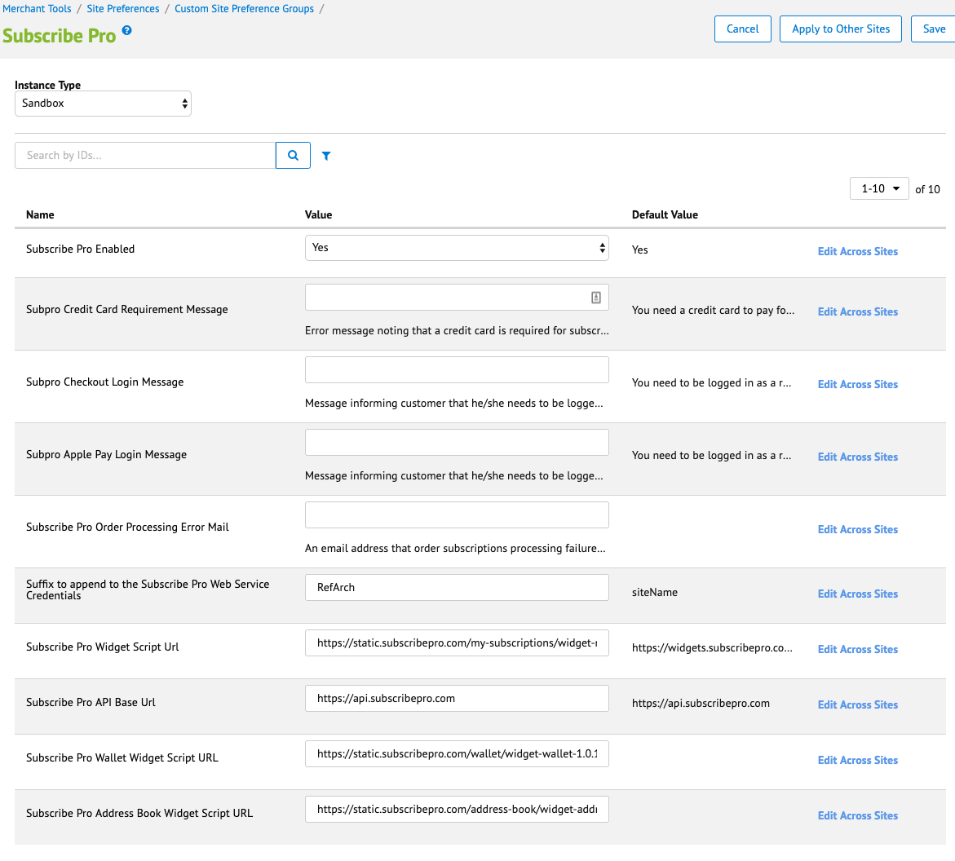

## Storefront Functionality

### Product Detail Page

When the product page template has been updated, you should be able to see subscription options for product: one time delivery or regular delivery and drop down with delivery intervals if regular delivery is available. This information will be shown only for products for which subscription is configured in SFCC Business Manager and in Subscribe Pro Business Manager.

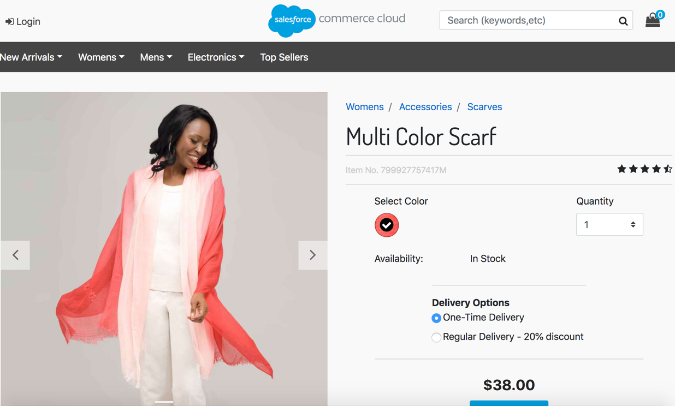

### 

### Cart Page

If any product with subscription was added to basket, on cart page you will see the same subscription options as on PDP for such product line item. At this step subscription options can be changed. To apply changes you’ll need to click on ‘Update Cart’ button.

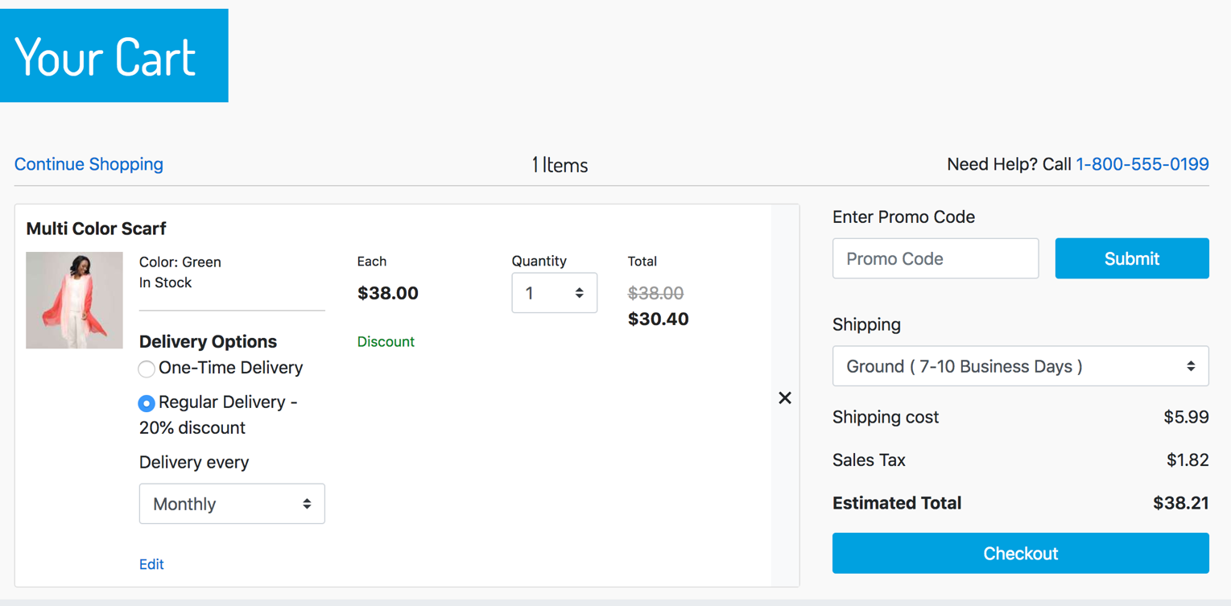

### Login Page

If customer has any product with regular subscription option selected, he/she must be logged in as a registered customer to place order with subscriptions. In other case customer will see error message informing that he/she should log in to proceed. ‘Checkout as Guest’ option is excluded.

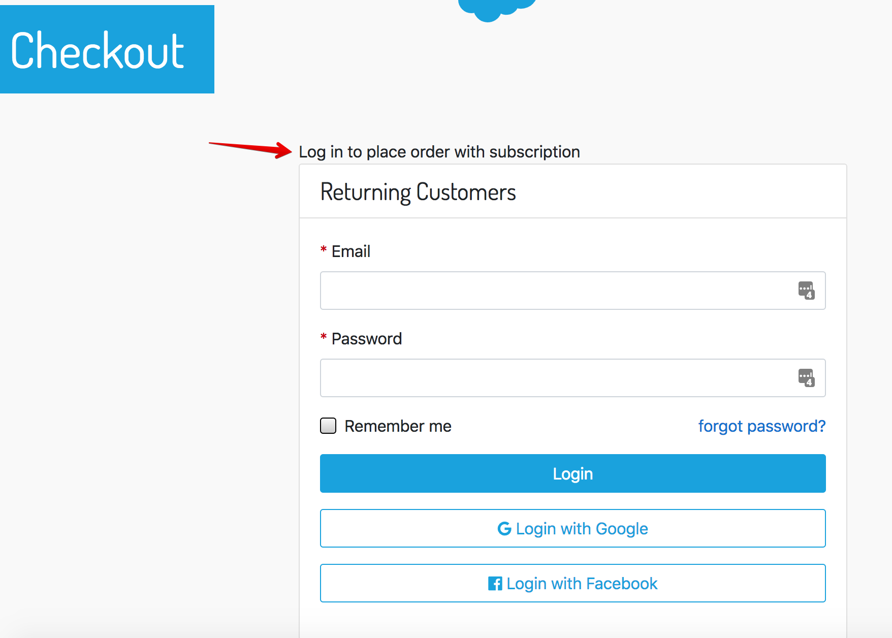

### Order Summary Right Rail and Minicart

For products with subscription selected options will be shown on Order Summary Right Rail block and on Minicart.

MiniCart:

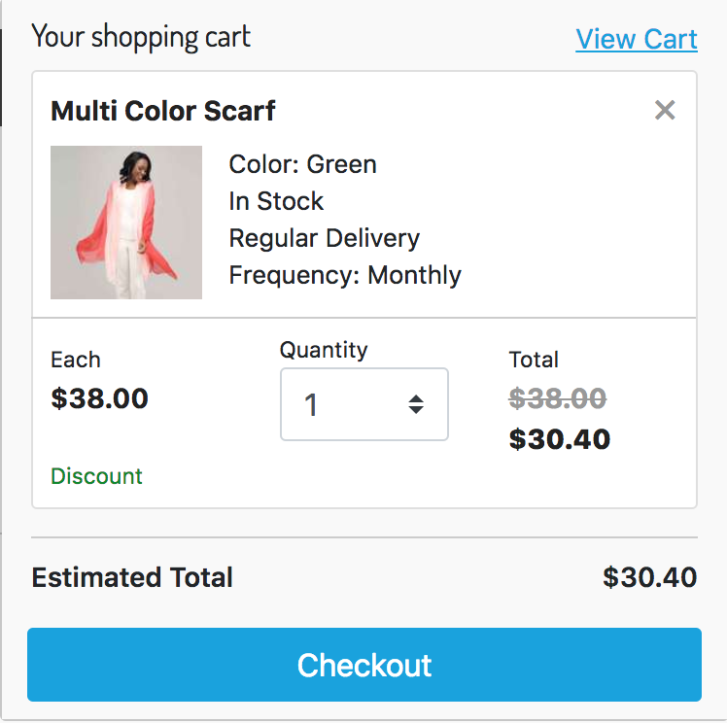

Right Rail:

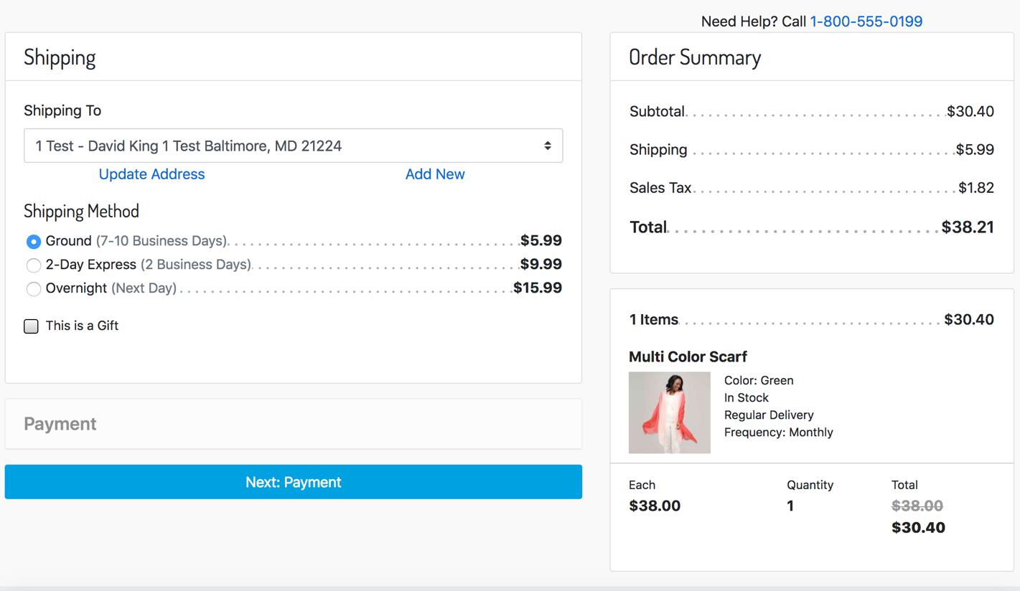

### Order Confirmation Page

When the order summary page template has been updated, you should be able to see selected subscription options for product in order.

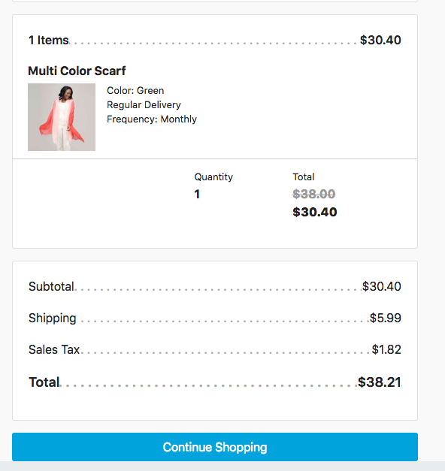

# Known Issues

# Release History

|  |  |  |
| --- | --- | --- |
| **Version** | **Date** | **Changes** |
| 17.1.0 | <DATE> | Initial release |